Assembly: Is our Society Racist? 15 June
Multiple Choice Quiz:
- What was the name of the man killed by a police officer in the USA?
  - Lloyd George
  - George Floyd
  - Stephen Lawrence
  - Edward Colston

- What ‘movement’ did Martin Luther King lead in the 1950s and 60s?
  - Civil rights
  - White supremacy
  - Black supremacy
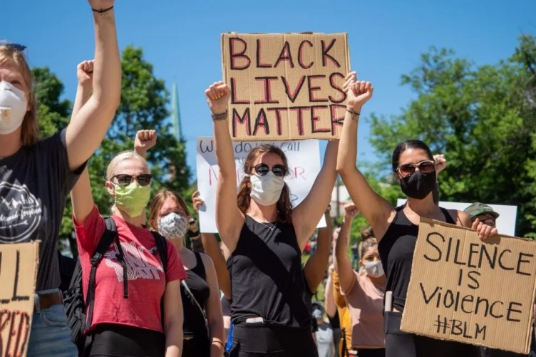
  - BAME supremacy

- What % of the population are white British, as recorded in the 2011 census?
  - 56%
  - 66%
  - 76%
  - 86%

- When is the next census due?
  - Next week
  - Next year
  - Every 10 years
  - Every year

- What % of the 1000 most powerful people in our country are from a BAME background?
  - 3%
  - 13%
  - 23%
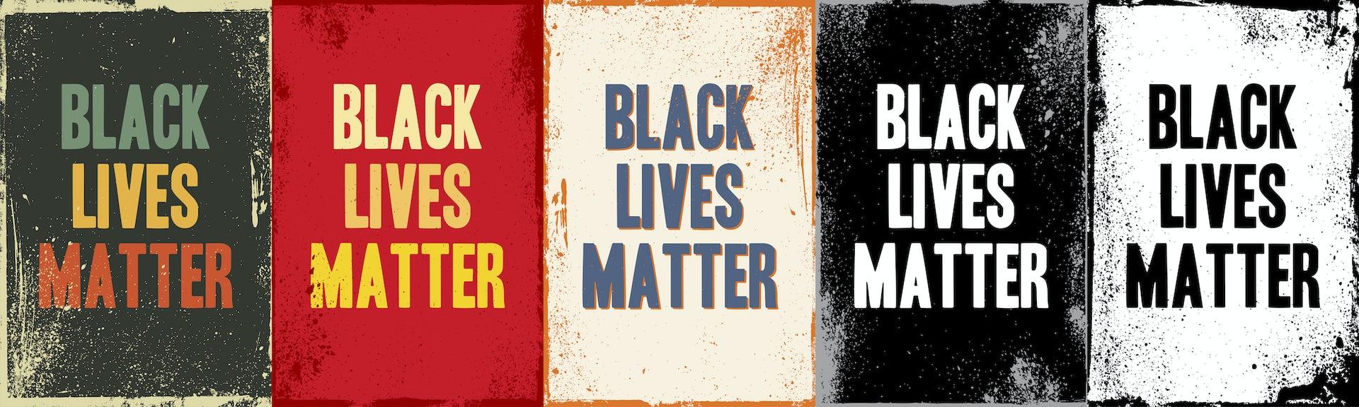
  - 33%

- The statue of Edward Colston was pulled down by protestors but in which city?
  - Bristol
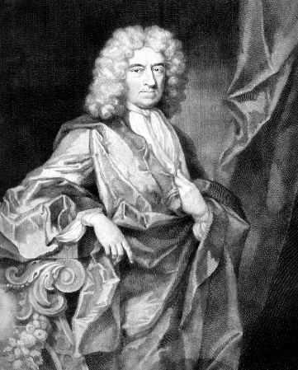
  - Birmingham
  - Burnley
  - Bolton
- What is a philanthropist?
  - A slave trader
  - Somebody interested in racism
  - Somebody interested in dinosaurs
  - Somebody who helps others using their own money

- How many African men, women and children did the Royal Africa Company transport from Africa to the Caribbean as slaves?
  - 24000
  - 44000
  - 54000
  - 84000

- How many are estimated to have died?
  - 90
  - 900
  - 9,000
  - 19,000

- What doe BAME stand for?
  - British And Minority Ethnic
  - Black And Minority Ethnic
  - Black, Asian and Minority Ethnic
  - British, AMerican, European
