June 2020

Dear Parent/carer

Re: School Lockers

Here at Chamberlayne we have lockers available for our students. We outsourced the allocation of this facility to a company called Prefect Equipment. They manage the process of locker rental. You pay the company by logging onto the following website: www.locker.rentals. By following the instructions on screen, you can book and pay the year’s rental of £18.00 and the company will provide you with the combination code for the locker that your child is allocated. The codes are unique to each locker and unless your child shares the code with friends, no one else will know what that combination is.

If you would be interested in renting a locker, please e mail me at: lockers@chamberlayne.org giving me the name of your child so that I am able to keep our school records up to date and go online to the website above to make your payment.

Should you have any questions regarding the content of this letter, please do not hesitate to contact me.

Yours sincerely
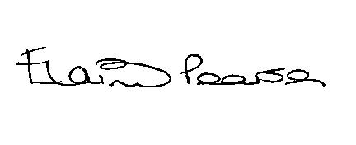

Elaine Pearson

Business & Finance Manager

